**SQL**

Creation of database

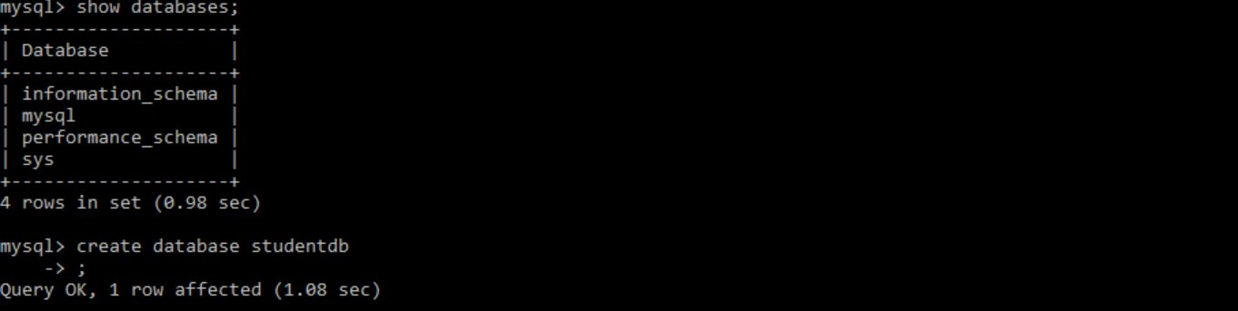

**Create:**

Creation of a table

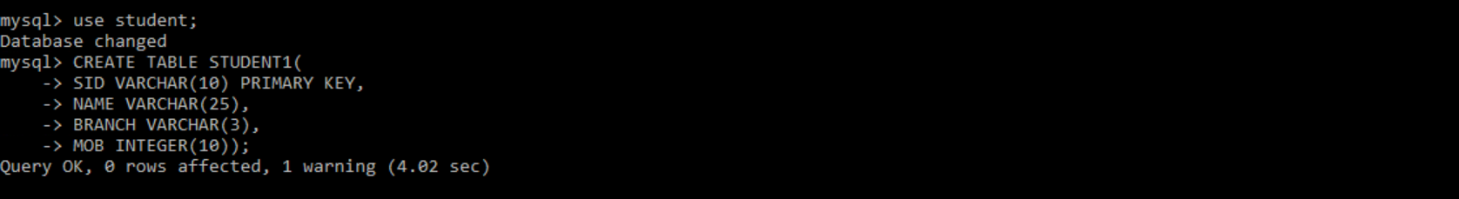

**DESC**

It will describe the structure of a table

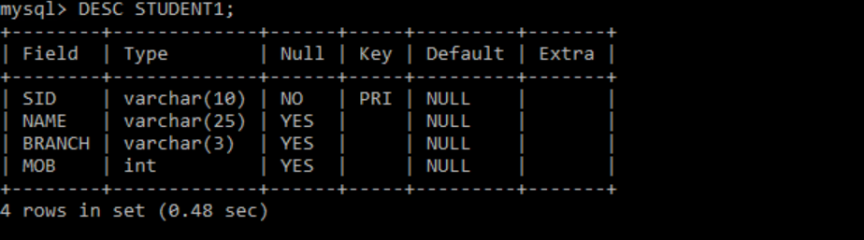

**Insert**

Inserting a value into a table by insert command

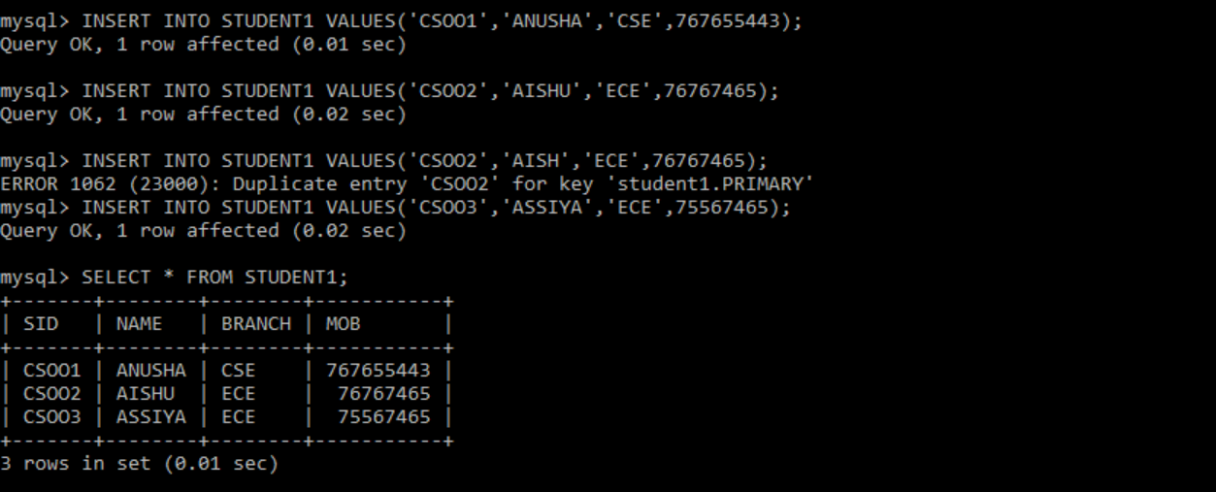

**Select**

